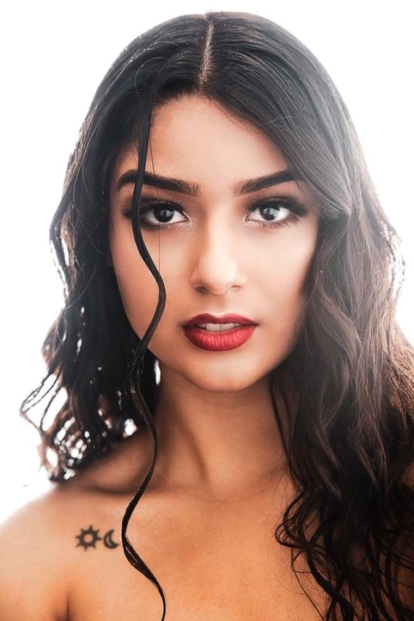

**Abi Luz**

Model/Actress

Email: [luzgarciabooking@gmail.com](mailto:luzgarciabooking@gmail.com)

Mobile: 940-210-4791

Instagram: @_abigarcia

Height: 5’7”

Build: Average

Eyes: Dark Brown

Hair: Dark Brown with Highlights

Nationality: Mexican American

Playing Age: 17-26

Bilingual: English, Spanish

**Education**

2019-2020 John Casablancas Modeling and Acting School Dallas,Tx

2020-2021 Online Modeling Classes with Kiara Belen-America’s Next Top Model contestant

**Professional Work**

**Commercial**

S2 Medco

Patient

IllusionMedia Works

**Film/TV**

Weight and Distance

Sister

IllusionMedia Works

**Commercial**

Fito’s Tacos de Trompo

Costumer

Seam productions

**Commercial**

El Viejon Seafood Restaurant

Costumer

Seam Productions

**Modeling**

**Runway**

Rulli Torres Pink Fashion Show 2020

New York Fashion Week 2021

London Fashion Week 2021

**Promotional**

Promotional videos for Rulli Torres Pink Fashion Show 2022

Freelance Modeling shoots for photographer’s portfolios 2019-2022